Lab SQS

Create Queue:

1. Go to SQS on AWS console 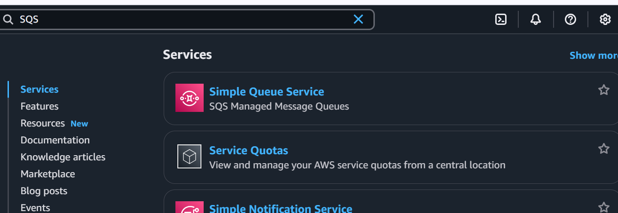
2. Click ‘**Create queue**’.

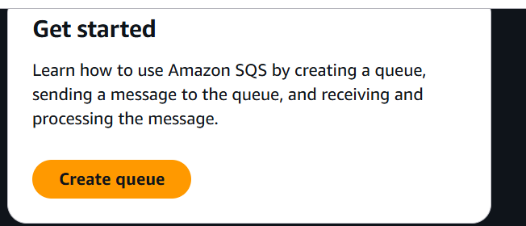

1. Provide queue a name, and create standard queue

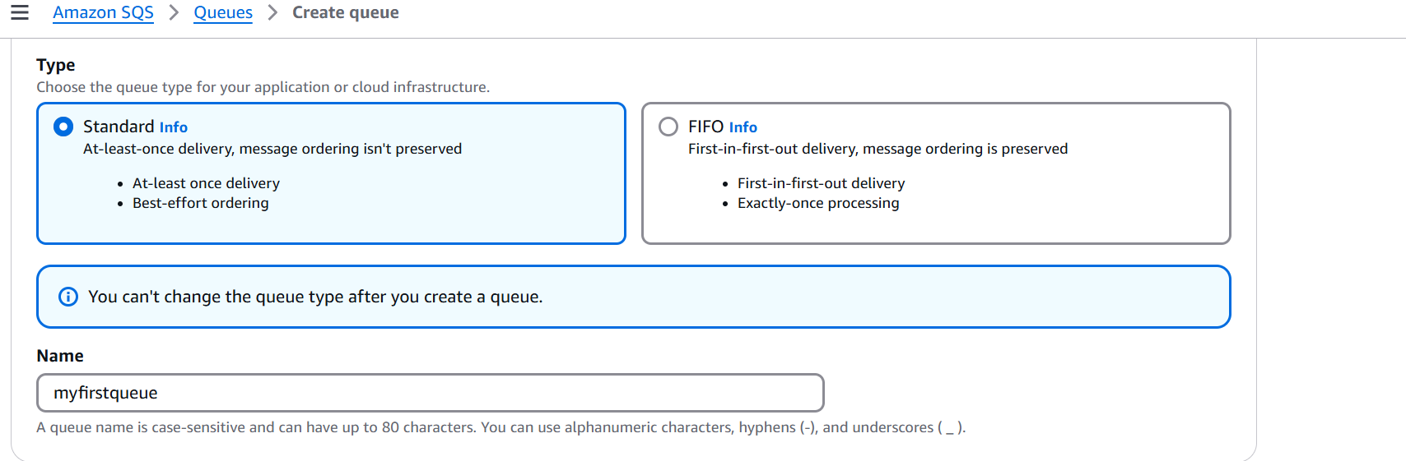

1. All the other parameters keep it default
2. Click on send and receive message

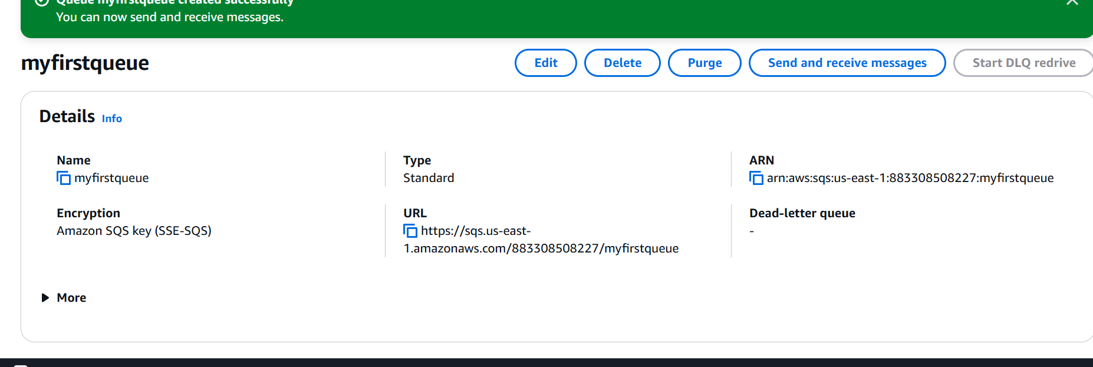

**Send message** section **Message body :** "This is the first message for SQS."

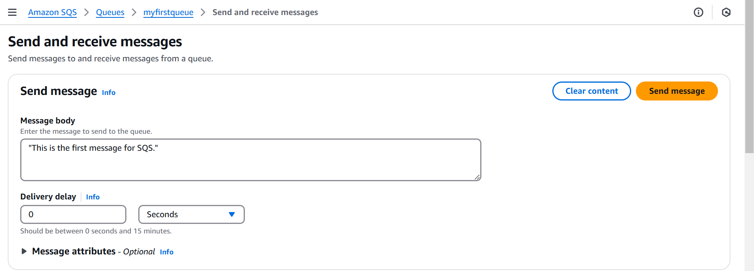

* Keep the rest as default.
* Click ‘**Send message**’.
* Look at ‘**Receive messages**’ section >>> ‘**Messages available**’ = 1.

1. **Step 3 : Poll for Messages**

Click ‘**Poll for messages**’ under ‘**Receive messages**’.

Click on the polled message under ‘**Messages**’.

Look at the message.

Click ‘**Done**’.

Select the polled message and click ‘**Delete**’ to delete the message.

